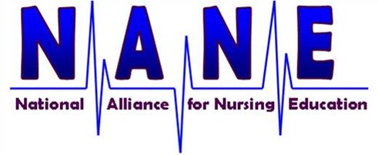:

August 1, 2019

TO: Selected Executives of Hospital-Based Nursing Colleges

FROM: Paul Lee, Senior Partner, Strategic Health Care

Hospital-based schools of nursing and allied health are facing increasing challenges in maintaining their Medicare pass-through funding.

- After numerous meetings with Trump Administration officials over the past six months, there is little interest in helping hospital-based schools with changes that would update 25-year-old Medicare regulations that hinder compliance.
- Over the past few weeks, we have received reports of fiscal intermediary audits that make it clear CMS is interested in reigning-in spending for hospital-based schools. This is in addition to previous reports of government audits that are challenging the very existence of a number of schools.
- The government is continuing to change its accountability standards for accrediting organizations, which further underscores the need to make current Medicare pass-through regulations more accommodating.

For the past several years, we have successfully worked with our hospital-based nursing school coalition to protect current Medicare pass-through payments and modify changes to accreditation requirements that threatened the future of many schools. Because we garnered the support of dozens of members of Congress who pushed legislation and held a series of meeting with top HHS and CMS officials, our coalition kept the funds flowing to every program.

The Coalition is the only organization devoted exclusively to advancing the policy objectives of hospital-based schools that receive Medicare pass-through payments – with a laser-focus on assuring the continuation of this government funding.

Each of your programs has benefited from this coalition effort. According to an analysis of hospital cost reports, in 2017:

12 nursing colleges received more than $2 million a year in Medicare pass-through payments (see attached spreadsheet). 32 schools received more than $1 million a year. 26 schools received between $500,000 and $1 million a year. This doesn’t take into account funding for allied health schools, which are also threatened.

Over the past few months, I have spoken with many of our nursing school deans about their interest in maintaining a strong advocacy and policy effort to assure the continuation of Medicare pass-through payments to hospital-based schools. Without exception, there is support for continuing our coalition.

During the past few years, a very small number of schools have provided financial support for the coalition’s efforts. In particular, Blessing Reiman College of Nursing and Kettering College for Healthcare have provided 90 percent of the funding. The coalition is very grateful for their support, but it is time to ask other colleges to help contribute to the ongoing success.

I am proposing a very simple coalition funding proposal:

FY17 Medicare Pass-Through Payment Coalition Fee
Up to $1 million $800 a month
$1M to $2M $1,000 a month
Over $2M $1,200 a month

We need to raise $15,000 a month to finance our work on your behalf. If we have more than 15 colleges agree to contribute, we will reduce fees to everyone on a pro-rata basis.

As an added benefit of being a financial contributor, you will:

- Be a member of the Coalition’s Executive Committee
  - Committee will schedule monthly conference calls, and more as necessary
  - Committee will set the agenda for the Coalition
- Be tapped first to participate in Coalition meetings with HHS, CMS and Congress
- Participate in all Coalition policy development, both regulatory and legislative initiatives
- Approve, by consensus, all Coalition policy.

I have attached a NANE Membership Form. Please complete as soon as possible and email to me. I would be pleased to talk with you personally if you have further questions or suggestions.

We have a challenging task ahead but working together I believe we can secure the changes we need to assure continued federal financial support for hospital-based nursing schools that receive Medicare pass-through payments from their host hospitals.

